**IMPLEMENTING THE BOOKING OF TICKET LOGIC**

The next task in the project is to **book a ticket**. However this task is itself divided into following subtasks:

1. Accept the passenger details with all the validations applied

2.While accepting the details , allow the user to cancel the process in between

3.After all the input has been received , check whether the seats are available or not .

4. If seat is available , then book the ticket and generate the ticket number otherwise print the message **SEATS FULL** .**We assume that we have 30 seats per train per class.**

We have divided the above requirements into multiple functions:

1. **Passenger * get_passenger_details()** : This function will accept all data about the **passenger** and ticket to be booked with all the validations applied. If the input is correct it will return the address of **Passenger structure variable** and if the user cancels the process in between it returns **NULL**.

2. **int check_train_no(char *)**: This function will accept a train number as argument and check whether a train with that number exists or not. If the train exists it **return 1** otherwise it **returns 0**

3. **int get_booked_ticket_count(char *,char)**:This function will accept a train number and the travelling class (F or S) as argument and count and **return number of tickets** booked in the given train in the given class.

4. **int last_ticket_no()**: This function will count and return the **ticket no** of last booked ticket and if no tickets have been booked it will **return 0**

5. **int book_ticket(Passenger)**: This function will accept the Passenger variable as argument and book the ticket. If booking is successful it will **return 1** otherwise it will **return 0**.

So before proceeding further make the following declarations in the header file **"rlyres.h"**

**Passenger * get_passenger_details();**

**int check_train_no(char *);**

**int get_booked_ticket_count(char *,char);**

**int last_ticket_no();**

**int book_ticket(Passenger);**

**DESIGNING THE "check_train_no()" FUNCTION IN THE FILE "rlyres.c"**

This function will accept a train number as argument and check whether a train with that number exists or not. If the train exists it **return 1** otherwise it **returns 0**

Following is it's prototype:

**int check_train_no(char *);**

This function will do the following:

1. Open the file **alltrains.dat**

2. **Run a loop** and **read each record** of a Train from the file

3. **Compare** the **train number passed as argument** with **the train number of the record read**.

4.If the match occurs then **return 1** other wise **read the next record**.

5.Finally , if all records are read and the train number is not found then **return 0**.

Following is it's code:

***int check_train_no(char *trainno)***

***{***

***}***

**DESIGNING THE "get_passenger_details()" FUNCTION IN THE FILE "rlyres.c"**

To understand how the function **get_passenger_details()** will be designed , we must have a look at some screenshots this function produces:

1. The first screen prompts the user to input his/her name as well as it displays the message "**Press 0 to exit**" at the **top right corner** and this message is displayed continuously.

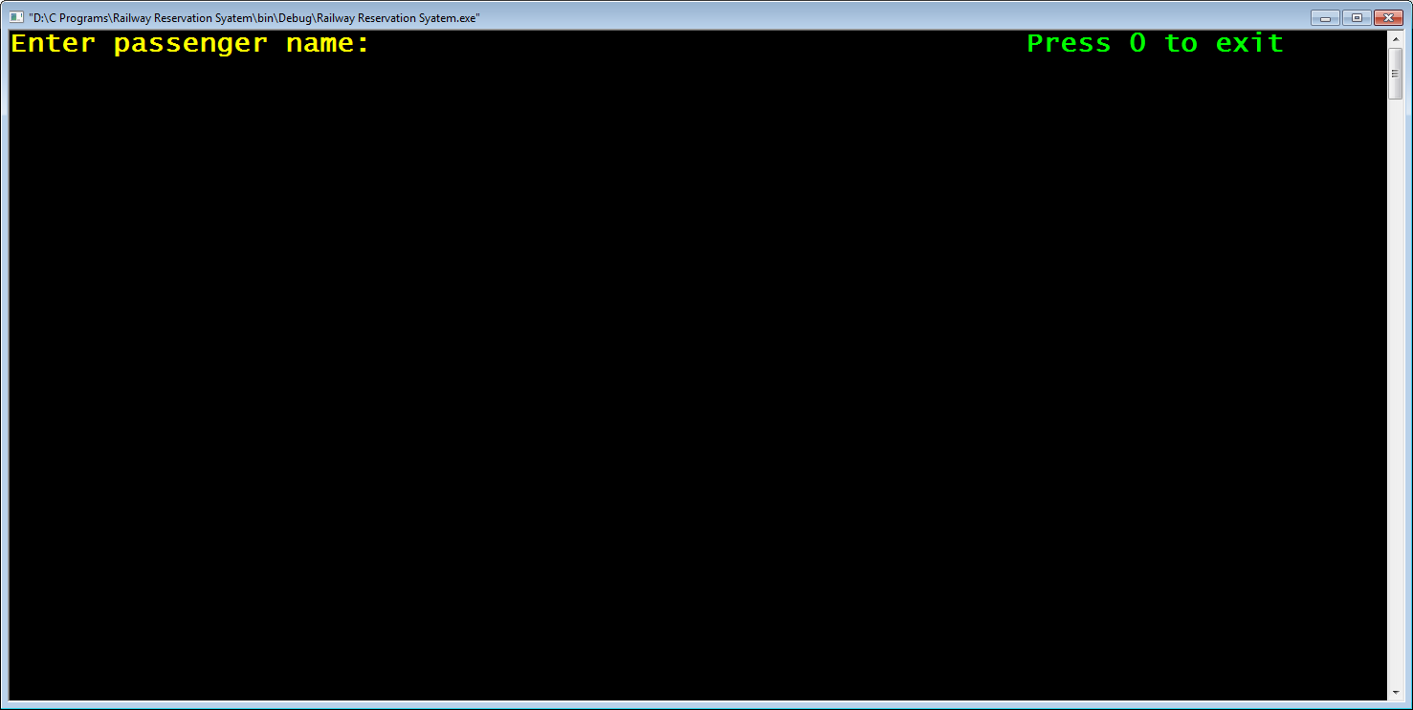

2. After the user inputs his name , the function prompts the user to input his/her gender as **M** or **F**.If any other character is inputted it generates an error message at the **bottom of the screen** as "**Error! Gender should be M or F (in uppercase)**"

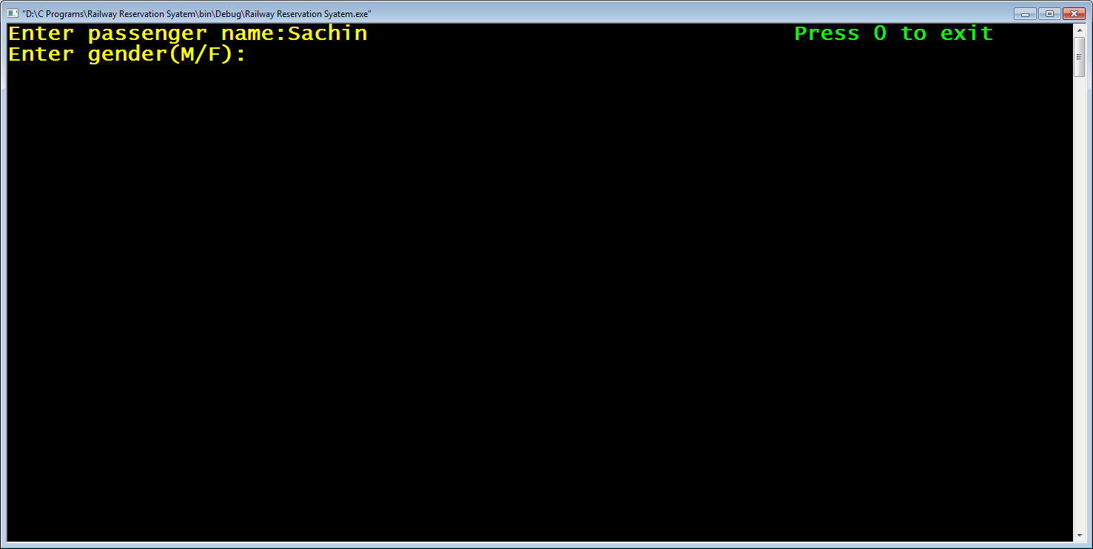

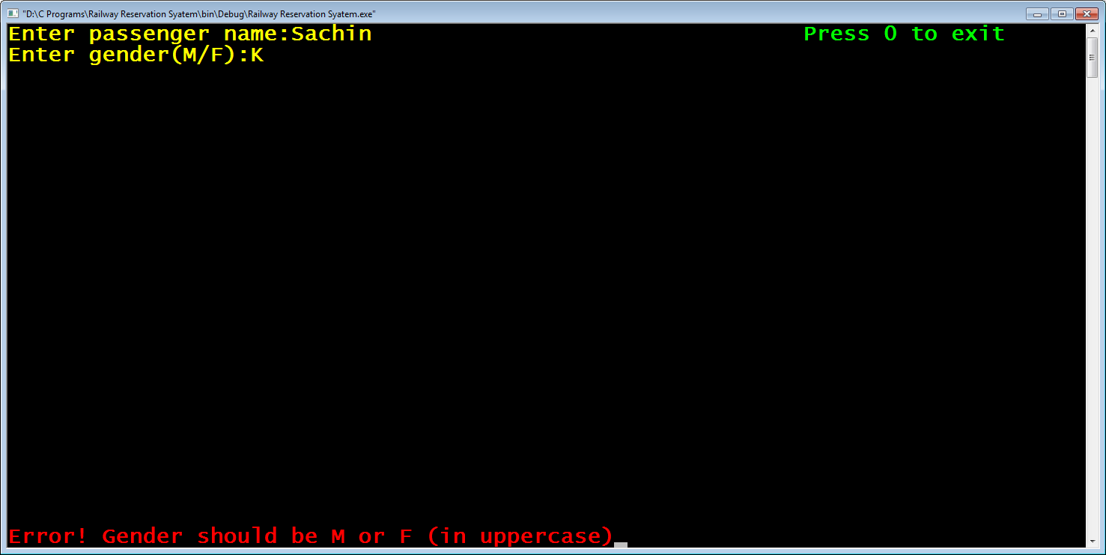

3. The code then again waits for the correct input

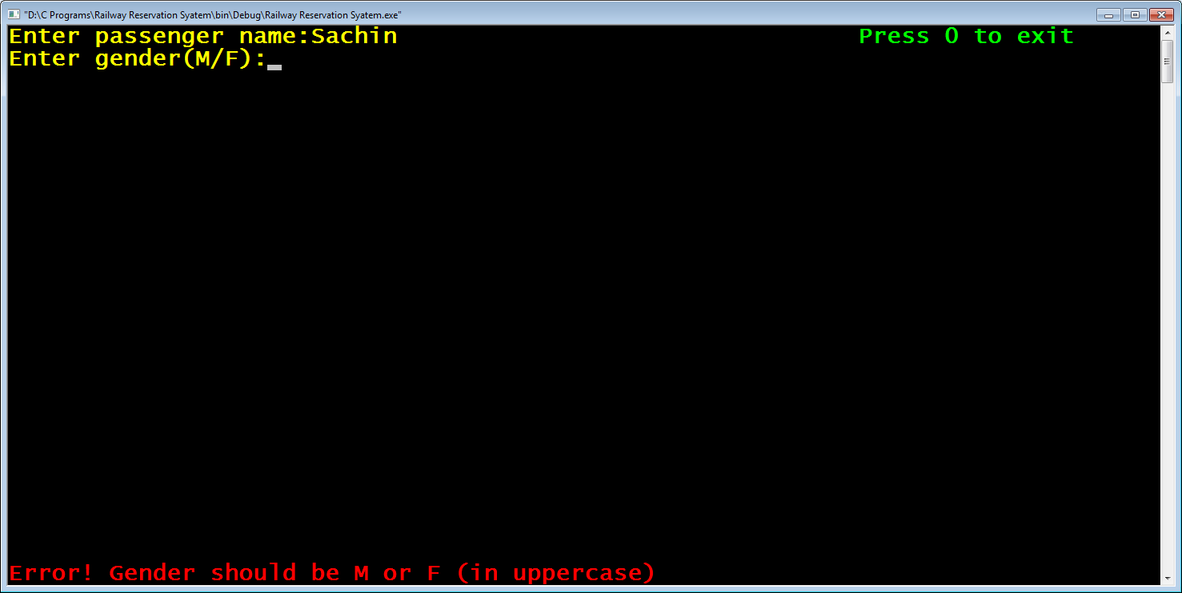

4. After correct gender is given the code , prompts the user to input **train number**

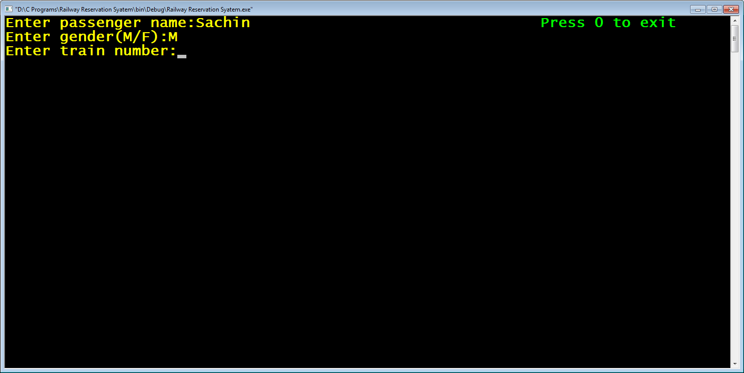

5. It then checks whether train number is valid or not . If it is invalid , it displays the error message as "**Error ! Invalid Train No**".

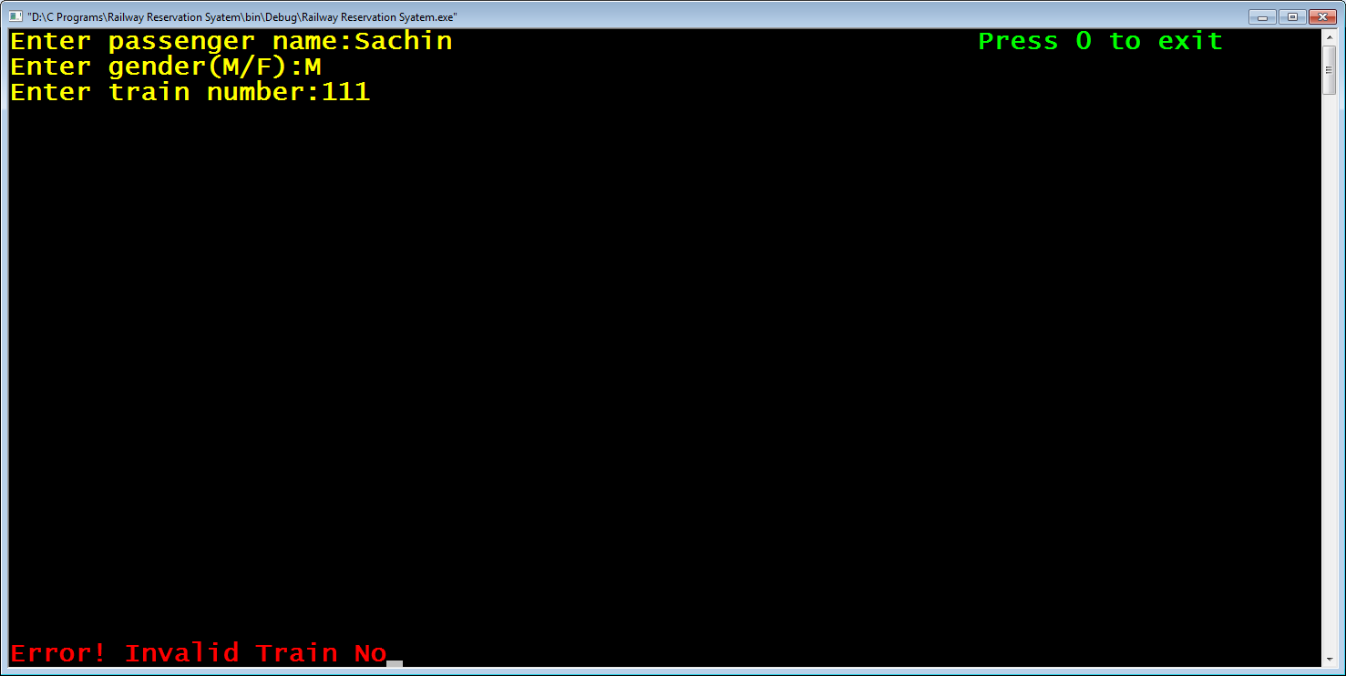

6.The code then again waits for the correct input

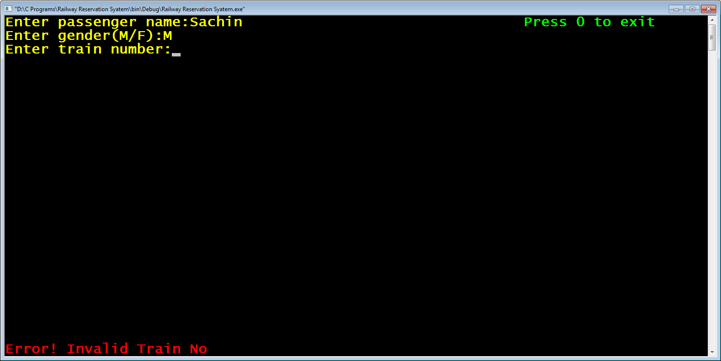

7. If correct train number is given , the code prompts the user to input **travelling class** as **F** or **S**

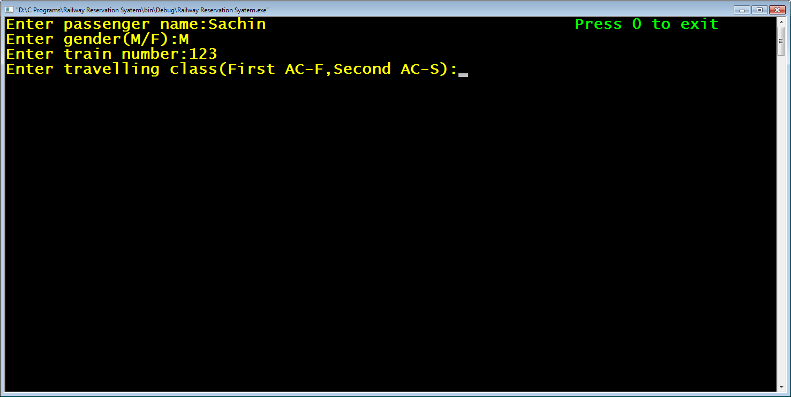

8. Like this , the code accepts all the inputs with validations.

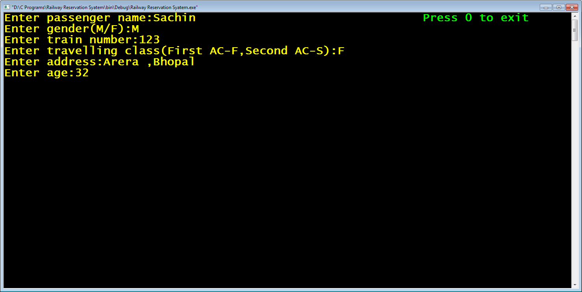

9. Also , if during these inputs the user types 0 as input , then the function displays the message "**Reservation Cancelled**" and stops accepting further inputs

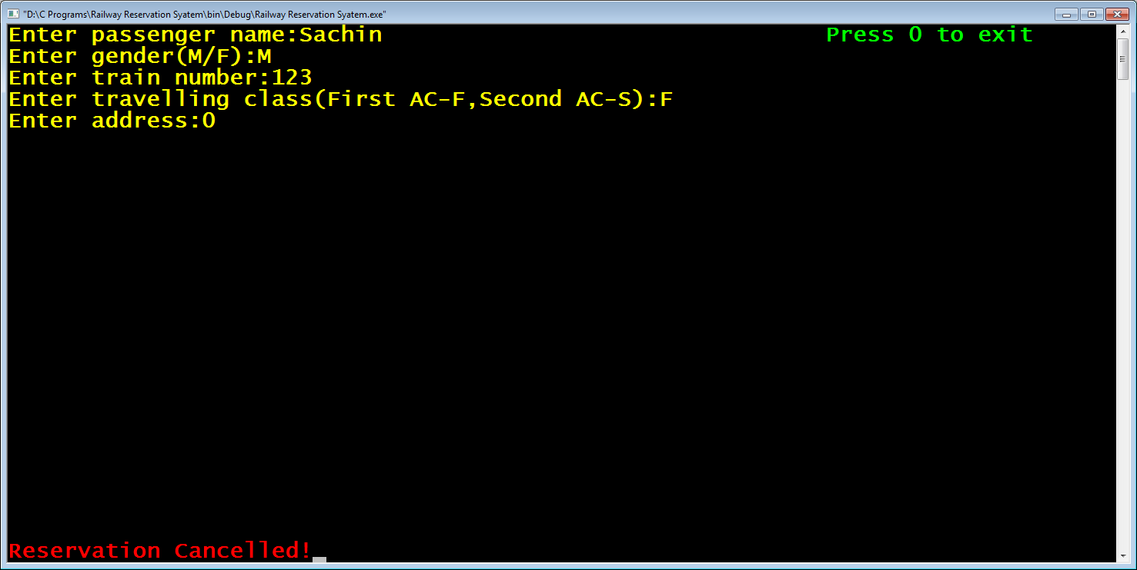

Following are the stepwise details of the function **get_passenger_details()**:

1. **Display the message "Press 0 to exit" at the top right corner**

For this we need to call the functions **gotoxy()** , **textcolor()** and **printf()** with appropriate arguments.

Here is the code for that:

***gotoxy(40,1);***

***textcolor(LIGHTGREEN);***

***printf("Press 0 to exit");***

2. **Accept passenger name from the user and if he presses 0 then display the message "Reservation Cancelled" and return back**

For this following steps are required:

a. Set the cursor at the location **1,1** as well as set the font color to **YELLOW**

Here is the code for it:

***gotoxy(1,1);***

***textcolor(YELLOW);***

***printf("Enter passenger name:");***

b. Declare a **static** variable of type **Passenger**

c. Accept input using the function **fgets( )** ( we are not using the function **gets()** because it suffers from the problem of buffer overflow and it is not at all recommended to be used , while the function **fgets()** has no such problem)

Here is the code for it:

***static Passenger psn;***

***fflush(stdin);***

***fgets(psn.p_name,20,stdin);***

d. The function **fgets()** has 1 problem. It appends the extra newline character at the end of the input when the user strikes **ENTER** key . So we have to remove the extra newline character that **fgets()** appends at the end.

e. For this we have a function called **strchr()** available in the header file **string.h** . It's prototype is:

**int * strchr(char *,char);**

This function accepts a string and a character as argument and returns it's **address** in the given string . So we will search for the **address** of **'\n'** in the string and overwrite **'\0'** at that **address**

Here is the code for it:

***char *pos;***

***pos=strchr(psn.p_name,'\n');***

***\*pos='\0';***

f. Check if 0 has been entered . If the user has entered 0 then move to bottom coordinate (1,25) of the screen using **gotoxy()**, set the color to **LIGHTRED** using **textcolor()** ,print the message "**Reservation Cancelled**" , reset the color to **YELLOW** and return **NULL**.

Here is the code for it:

***if(strcmp(psn.p_name,"0")==0)***

***{***

***textcolor(LIGHTRED);***

***gotoxy(1,25);***

***printf("Reservation Cancelled!");***

***getch();***

***textcolor(YELLOW);***

***return NULL;***

***}***

So for all the above steps the combined code will be:

***Passenger * get_passenger_details()***

***{***

***clrscr();***

***gotoxy(60,1);***

***textcolor(LIGHTGREEN);***

***printf("Press 0 to exit");***

***gotoxy(1,1);***

***textcolor(YELLOW);***

***static Passenger psn;***

***printf("Enter passenger name:");***

***fflush(stdin);***

***fgets(psn.p_name,20,stdin);***

***char *pos;***

***pos=strchr(psn.p_name,'\n');***

***\*pos='\0';***

***if(strcmp(psn.p_name,"0")==0)***

***{***

***textcolor(LIGHTRED);***

***gotoxy(1,25);***

***printf("Reservation Cancelled!");***

***getch();***

***textcolor(YELLOW);***

***return NULL;***

***}***

3. **Accept gender from the user .If he presses 0 then display the message "Reservation Cancelled" and return back , if he inputs anything other than 'M' or 'F' then display the message** "**Error! Gender should be M or F (in uppercase)**" **and again wait for the input. Repeat this process until the input is either** '**M**' **or** '**F**' **then proceed to accept the next input**

For this following steps are required:

a. Prompt the user to input gender.

b. Run a loop which does the following:

i) accept the input

ii)if the input received is 0 then move to bottom coordinate (1,25) of the screen using **gotoxy()**, **erase the previous message** , set the color to **LIGHTRED** using **textcolor()** ,print the message "**Reservation Cancelled**" , reset the color to **YELLOW** and return **NULL**.

Here is the code for it:

***int valid;***

***printf("Enter gender(M/F):");***

***do***

***{***

***valid=1;***

***fflush(stdin);***

***scanf("%c",&psn.gender);***

***if(psn.gender=='0')***

***{***

***textcolor(LIGHTRED);***

***gotoxy(1,25);***

***printf("\t\t\t\t\t\t\t");***

***gotoxy(1,25);***

***printf("Reservation Cancelled!");***

***getch();***

***textcolor(YELLOW);***

***return NULL;***

***}***

iii)if the input received is neither '**M**' nor '**F**' then move to bottom coordinate (1,25) of the screen using **gotoxy()**, , set the color to **LIGHTRED** using **textcolor()** ,print the message " **Error! Gender should be M or F (in uppercase)**" , move back to coordinate (19,2) , erase the entered character and reset the color to **YELLOW** .

iv) Repeat this until input received is '**M**' or '**F**'

v) After the loop is over , erase the error message from bottom coordinate (1,25)

Here is the code for it:

***if(psn.gender!='M' && psn.gender!='F')***

***{***

***textcolor(LIGHTRED);***

***gotoxy(1,25);***

***printf("Error! Gender should be M or F (in uppercase)");***

***valid=0;***

***getch();***

***gotoxy(19,2);***

***printf(" \b");***

***textcolor(YELLOW);***

***}***

***}while(valid==0);***

***gotoxy(1,25);***

***printf("\t\t\t\t\t\t\t");***

So for all the above steps the combined code will be:

***int valid;***

***printf("Enter gender(M/F):");***

***do***

***{***

***valid=1;***

***fflush(stdin);***

***scanf("%c",&psn.gender);***

***if(psn.gender=='0')***

***{***

***textcolor(LIGHTRED);***

***gotoxy(1,25);***

***printf("\t\t\t\t\t\t\t");***

***gotoxy(1,25);***

***printf("Reservation Cancelled!");***

***getch();***

***textcolor(YELLOW);***

***return NULL;***

***}***

***if(psn.gender!='M' && psn.gender!='F')***

***{***

***textcolor(LIGHTRED);***

***gotoxy(1,25);***

***printf("Error! Gender should be M or F (in uppercase)");***

***valid=0;***

***getch();***

***gotoxy(19,2);***

***printf(" \b");***

***textcolor(YELLOW);***

***}***

***}while(valid==0);***

***gotoxy(1,25);***

***printf("\t\t\t\t\t\t\t");***

4. **Accept train number from the user .If he presses 0 then display the message "Reservation Cancelled" and return back. Check whether the train number is valid or not . If it is invalid then display the message** "**Error! Invalid Train No**" **and again wait for the input. Repeat this process until the user inputs a valid train number and**  **then proceed to accept the next input**

For this following steps are required:

a. Set the cursor to **coordinate (1,3)** and prompt the user to **input train number**.

b. Run a loop which does the following:

i) accept the input

ii)if the input received is 0 then move to bottom coordinate (1,25) of the screen using **gotoxy()**, **erase the previous message** , set the color to **LIGHTRED** using **textcolor()** ,print the message "**Reservation Cancelled**" , reset the color to **YELLOW** and return **NULL**.

Here is the code for it:

***gotoxy(1,3);***

***printf("Enter train number:");***

***do***

***{***

***fflush(stdin);***

***scanf("%s",psn.train_no);***

***if(strcmp(psn.train_no,"0")==0)***

***{***

***textcolor(LIGHTRED);***

***gotoxy(1,25);***

***printf("\t\t\t\t\t\t\t");***

***gotoxy(1,25);***

***printf("Reservation Cancelled!");***

***getch();***

***textcolor(YELLOW);***

***return NULL;***

***}***

iii)Check whether the train number is valid or not by calling the function **check_train_no()** . If it is invalid then move to bottom **coordinate (1,25)** of the screen using **gotoxy()**, , set the color to **LIGHTRED** using **textcolor()** ,print the message " **Error! Invalid Train No**" , move back to **coordinate (20,3)** , erase the entered character and reset the color to **YELLOW** .

iv) Repeat this until a valid train number is entered.

v) After the loop is over , erase the error message from bottom coordinate (1,25)

Here is the code for it:

***valid=check_train_no(psn.train_no);***

***if(valid==0)***

***{***

***textcolor(LIGHTRED);***

***gotoxy(1,25);***

***printf("Error! Invalid Train No");***

***getch();***

***gotoxy(20,3);***

***printf("\t\t\t\t\t\t");***

***gotoxy(20,3);***

***textcolor(YELLOW);***

***}***

***}while(valid==0);***

***gotoxy(1,25);***

***printf("\t\t\t\t\t\t\t");***

So for all the above steps the combined code will be:

***gotoxy(1,3);***

***printf("Enter train number:");***

***do***

***{***

***fflush(stdin);***

***scanf("%s",psn.train_no);***

***if(strcmp(psn.train_no,"0")==0)***

***{***

***textcolor(LIGHTRED);***

***gotoxy(1,25);***

***printf("\t\t\t\t\t\t\t");***

***gotoxy(1,25);***

***printf("Reservation Cancelled!");***

***getch();***

***textcolor(YELLOW);***

***return NULL;***

***}***

***valid=check_train_no(psn.train_no);***

***if(valid==0)***

***{***

***textcolor(LIGHTRED);***

***gotoxy(1,25);***

***printf("Error! Invalid Train No");***

***getch();***

***gotoxy(20,3);***

***printf("\t\t\t\t\t\t");***

***gotoxy(20,3);***

***textcolor(YELLOW);***

***}***

***}while(valid==0);***

***gotoxy(1,25);***

***printf("\t\t\t\t\t\t\t");***

5. **Accept travelling class from the user .If he presses 0 then display the message "Reservation Cancelled" and return back , if he inputs anything other than 'F' or 'S' then display the message** "**Error! Travelling class should be F or S (in uppercase)**" **and again wait for the input. Repeat this process until the input is either** '**F**' **or** '**S**' **then proceed to accept the next input**

For this following steps are required:

a. Set the cursor to coordinate (1,4) and prompt the user to input travelling class.

b. Run a loop which does the following:

i) accept the input

ii)if the input received is 0 then move to bottom coordinate (1,25) of the screen using **gotoxy()**, **erase the previous message** , set the color to **LIGHTRED** using **textcolor()** ,print the message "**Reservation Cancelled**" , reset the color to **YELLOW** and return **NULL**.

Here is the code for it:

***gotoxy(1,4);***

***printf("Enter travelling class(First AC-F,Second AC-S):");***

***do***

***{***

***valid=1;***

***fflush(stdin);***

***scanf("%c",&psn.p_class);***

***if(psn.p_class=='0')***

***{***

***textcolor(LIGHTRED);***

***gotoxy(1,25);***

***printf("\t\t\t\t\t\t\t");***

***gotoxy(1,25);***

***printf("Reservation Cancelled!");***

***getch();***

***textcolor(YELLOW);***

***return NULL;***

***}***

iii)if the input received is neither '**F**' nor '**S**' then move to bottom coordinate (1,25) of the screen using **gotoxy()**, , set the color to **LIGHTRED** using **textcolor()** ,print the message " **Error! Travelling class should be F or S (in uppercase)**" , move back to coordinate (48,4) , erase the entered character and reset the color to **YELLOW** .

iv) Repeat this until input received is '**F**' or '**S**'

v) After the loop is over , erase the error message from bottom coordinate (1,25)

Here is the code for it:

***if(psn.p_class!='F' && psn.p_class!='S')***

***{***

***textcolor(LIGHTRED);***

***gotoxy(1,25);***

***printf("Error! Travelling class should be F or S (in uppercase)");***

***valid=0;***

***getch();***

***gotoxy(48,4);***

***printf(" \b");***

***textcolor(YELLOW);***

***}***

***}while(valid==0);***

***gotoxy(1,25);***

***printf("\t\t\t\t\t\t\t");***

So for all the above steps the combined code will be:

***gotoxy(1,4);***

***printf("Enter travelling class(First AC-F,Second AC-S):");***

***do***

***{***

***valid=1;***

***fflush(stdin);***

***scanf("%c",&psn.p_class);***

***if(psn.p_class=='0')***

***{***

***textcolor(LIGHTRED);***

***gotoxy(1,25);***

***printf("\t\t\t\t\t\t\t");***

***gotoxy(1,25);***

***printf("Reservation Cancelled!");***

***getch();***

***textcolor(YELLOW);***

***return NULL;***

***}***

***if(psn.p_class!='F' && psn.p_class!='S')***

***{***

***textcolor(LIGHTRED);***

***gotoxy(1,25);***

***printf("Error! Travelling class should be F or S (in uppercase)");***

***valid=0;***

***getch();***

***gotoxy(48,4);***

***printf(" \b");***

***textcolor(YELLOW);***

***}***

***}while(valid==0);***

***gotoxy(1,25);***

***printf("\t\t\t\t\t\t\t");***

6. **Accept address from the user .Replace newline with '\0' . Check If the user has pressed 0 or not as input. If he has pressed 0 then display the message Reservation Cancelled" and return back. Proceed to accept the next input**

For this following steps are required:

a. Set the cursor to **coordinate (1,5)** and prompt the user to **input address** and accept input.

b. Replace '\n' with '\0'

c. if the input received is 0 then move to bottom coordinate (1,25) of the screen using **gotoxy()**, **erase the previous message** , set the color to **LIGHTRED** using **textcolor()** ,print the message "**Reservation Cancelled**" , reset the color to **YELLOW** and return **NULL**.

Here is the code for it:

***printf("Enter address:");***

***fflush(stdin);***

***fgets(psn.address,20,stdin);***

***pos=strchr(psn.address,'\n');***

***\*pos='\0';***

***if(strcmp(psn.address,"0")==0)***

***{***

***textcolor(LIGHTRED);***

***gotoxy(1,25);***

***printf("\t\t\t\t\t\t\t");***

***gotoxy(1,25);***

***printf("Reservation Cancelled!");***

***getch();***

***textcolor(YELLOW);***

***return NULL;***

***}***

7. **Accept age from the user .If he presses 0 then display the message "Reservation Cancelled" and return back , if he inputs a negative value or 0 then display the message** "**Error! Age should be positive**" **and again wait for the input. Repeat this process until the input is positive and** **then proceed to accept the next input**

For this following steps are required:

a. Prompt the user to input age.

b. Run a loop which does the following:

i) accept the input

ii)if the input received is 0 then move to bottom coordinate (1,25) of the screen using **gotoxy()**, **erase the previous message** , set the color to **LIGHTRED** using **textcolor()** ,print the message "**Reservation Cancelled**" , reset the color to **YELLOW** and return **NULL**.

Here is the code for it:

***printf("Enter age:");***

***do***

***{***

***valid=1;***

***fflush(stdin);***

***scanf("%d",&psn.age);***

***if(psn.age==0)***

***{***

***textcolor(LIGHTRED);***

***gotoxy(1,25);***

***printf("\t\t\t\t\t\t\t");***

***gotoxy(1,25);***

***printf("Reservation Cancelled!");***

***getch();***

***textcolor(YELLOW);***

***return NULL;***

***}***

iii)if the input received is 0 or negative then move to bottom coordinate (1,25) of the screen using **gotoxy()**, , set the color to **LIGHTRED** using **textcolor()** ,print the message " **Error! Age should be positive**" , move back to coordinate (11,6) , erase the entered age and reset the color to **YELLOW** .

iv) Repeat this until input received is positive.

v) After the loop is over , accept the next input

Here is the code for it:

***if(psn.age<0)***

***{***

***textcolor(LIGHTRED);***

***gotoxy(1,25);***

***printf("Error! Age should be positive");***

***valid=0;***

***getch();***

***gotoxy(11,6);***

***printf("\t\t\t\t\t\t\t");***

***gotoxy(11,6);***

***textcolor(YELLOW);***

***}***

***}while(valid==0);***

***gotoxy(1,25);***

***printf("\t\t\t\t\t\t\t");***

***gotoxy(1,7);***

8. **Accept mobile no from the user .If he presses 0 then display the message "Reservation Cancelled" and return back , if he inputs alphanumeric or less than 10 digits then display the message** "**Error! Invalid mobile no**" **and again wait for the input. Repeat this process until the mobile number is correct and** **then proceed to accept the next input**

**Before we accept the mobile number , we must create a function called check_mob_no( ) that validates the mobile number.**

**DESIGNING THE "check_mob_no()" FUNCTION IN THE FILE "rlyres.c"**

This function will accept a mobile number as argument and check whether it is a valid mobile number exists or not. A mobile number is considered valid , if:

**i) It's length is exactly 10**

**ii)It doesn't contain any non numeric value.**

If the mobile number is valid the function will **return 1** otherwise it **returns 0**

Following is it's prototype:

**int check_mob_no(char *);**

This function will do the following:

1. It will check whether the length of mobile number is 10 or not using the function **strlen()**

2. If it's **length is not 10** then the function will **return 0**

3.Otherwise , it will run a loop and check whether each character is a digit or not using a function called

**isdigit( )** available in the header file **<ctype.h>** . This function accepts a character as argument and returns a **non zero value** if it is a digit otherwise it **returns 0**.

4. If any of the character's is not a digit , then the function **check_mob_no()** will **return 0**

5.Finally , if all the characters are digits then the function will **return 1**.

Following is it's code:

***int check_mob_no(char *p_mob)***

***{***

***if(strlen(p_mob)!=10)***

***return 0;***

***while(*p_mob!='\0')***

***{***

***if(isdigit(*p_mob)==0)***

***return 0;***

***p_mob++;***

***}***

***return 1;***

***}***

After , designing the function **check_mob_no()** , the next task is to **accept mobile number** in the function **get_passenger_details()**

For this following steps are required:

a. Prompt the user to input mobile number.

b. Run a loop which does the following:

i) accept the mobile number

ii)if the input received is 0 then move to bottom coordinate (1,25) of the screen using **gotoxy()**, **erase the previous message** , set the color to **LIGHTRED** using **textcolor()** ,print the message "**Reservation Cancelled**" , reset the color to **YELLOW** and return **NULL**.

Here is the code for it:

***printf("Enter mobile number:");***

***do***

***{***

***fflush(stdin);***

***scanf(“%s”,psn.mob_no);***

***if(strcmp(psn.mob_no,"0")==0)***

***{***

***textcolor(LIGHTRED);***

***gotoxy(1,25);***

***printf("\t\t\t\t\t\t\t");***

***gotoxy(1,25);***

***printf("Reservation Cancelled!");***

***getch();***

***textcolor(YELLOW);***

***return NULL;***

***}***

iii)Check whether the mobile number is valid or not using the function **check_mob_no()** . If it is invalid then move to bottom coordinate (1,25) of the screen using **gotoxy()**, , set the color to **LIGHTRED** using **textcolor()** ,print the message **Error! Invalid mobile no**" , move back to coordinate (21,7) , erase the entered value and reset the color to **YELLOW** .

iv) Repeat this until input received is correct.

v) After the loop is over , return the PASSENGER variable's address to the function main()

Here is the code for it:

***valid=check_mob_no(psn.mob_no);***

***if(valid==0)***

***{***

***textcolor(LIGHTRED);***

***gotoxy(1,25);***

***printf("Error! Invalid Mobile No");***

***getch();***

***gotoxy(21,7);***

***printf("\t\t\t\t\t\t");***

***gotoxy(21,7);***

***textcolor(YELLOW);***

***}***

***}while(valid==0);***

***return &psn;***

***}***

**THE COMPLETE CODE FOR THE FUNCTION get_passenger_details() IS:**

***Passenger * get_passenger_details()***

***{***

***clrscr();***

***gotoxy(60,1);***

***textcolor(LIGHTGREEN);***

***printf("Press 0 to exit");***

***gotoxy(1,1);***

***textcolor(YELLOW);***

***static Passenger psn;***

***printf("Enter passenger name:");***

***fflush(stdin);***

***fgets(psn.p_name,20,stdin);***

***char *pos;***

***pos=strchr(psn.p_name,'\n');***

***\*pos='\0';***

***if(strcmp(psn.p_name,"0")==0)***

***{***

***textcolor(LIGHTRED);***

***gotoxy(1,25);***

***printf("Reservation Cancelled!");***

***getch();***

***textcolor(YELLOW);***

***return NULL;***

***}***

***int valid;***

***printf("Enter gender(M/F):");***

***do***

***{***

***valid=1;***

***fflush(stdin);***

***scanf("%c",&psn.gender);***

***if(psn.gender=='0')***

***{***

***textcolor(LIGHTRED);***

***gotoxy(1,25);***

***printf("\t\t\t\t\t\t\t");***

***gotoxy(1,25);***

***printf("Reservation Cancelled!");***

***getch();***

***textcolor(YELLOW);***

***return NULL;***

***}***

***if(psn.gender!='M' && psn.gender!='F')***

***{***

***textcolor(LIGHTRED);***

***gotoxy(1,25);***

***printf("Error! Gender should be M or F (in uppercase)");***

***valid=0;***

***getch();***

***gotoxy(19,2);***

***printf(" \b");***

***textcolor(YELLOW);***

***}***

***}while(valid==0);***

***gotoxy(1,25);***

***printf("\t\t\t\t\t\t\t");***

***gotoxy(1,3);***

***printf("Enter train number:");***

***do***

***{***

***fflush(stdin);***

***scanf("%s",psn.train_no);***

***if(strcmp(psn.train_no,"0")==0)***

***{***

***textcolor(LIGHTRED);***

***gotoxy(1,25);***

***printf("\t\t\t\t\t\t\t");***

***gotoxy(1,25);***

***printf("Reservation Cancelled!");***

***getch();***

***textcolor(YELLOW);***

***return NULL;***

***}***

***valid=check_train_no(psn.train_no);***

***if(valid==0)***

***{***

***textcolor(LIGHTRED);***

***gotoxy(1,25);***

***printf("Error! Invalid Train No");***

***getch();***

***gotoxy(20,3);***

***printf("\t\t\t\t\t\t");***

***gotoxy(20,3);***

***textcolor(YELLOW);***

***}***

***}while(valid==0);***

***gotoxy(1,25);***

***printf("\t\t\t\t\t\t\t");***

***gotoxy(1,4);***

***printf("Enter travelling class(First AC-F,Second AC-S):");***

***do***

***{***

***valid=1;***

***fflush(stdin);***

***scanf("%c",&psn.p_class);***

***if(psn.p_class=='0')***

***{***

***textcolor(LIGHTRED);***

***gotoxy(1,25);***

***printf("\t\t\t\t\t\t\t");***

***gotoxy(1,25);***

***printf("Reservation Cancelled!");***

***getch();***

***textcolor(YELLOW);***

***return NULL;***

***}***

***if(psn.p_class!='F' && psn.p_class!='S')***

***{***

***textcolor(LIGHTRED);***

***gotoxy(1,25);***

***printf("Error! Travelling class should be F or S (in uppercase)");***

***valid=0;***

***getch();***

***gotoxy(48,4);***

***printf(" \b");***

***textcolor(YELLOW);***

***}***

***}while(valid==0);***

***gotoxy(1,25);***

***printf("\t\t\t\t\t\t\t");***

***gotoxy(1,5);***

***printf("Enter address:");***

***fflush(stdin);***

***fgets(psn.address,20,stdin);***

***pos=strchr(psn.address,'\n');***

***\*pos='\0';***

***if(strcmp(psn.address,"0")==0)***

***{***

***textcolor(LIGHTRED);***

***gotoxy(1,25);***

***printf("\t\t\t\t\t\t\t");***

***gotoxy(1,25);***

***printf("Reservation Cancelled!");***

***getch();***

***textcolor(YELLOW);***

***return NULL;***

***}***

***printf("Enter age:");***

***do***

***{***

***valid=1;***

***fflush(stdin);***

***scanf("%d",&psn.age);***

***if(psn.age==0)***

***{***

***textcolor(LIGHTRED);***

***gotoxy(1,25);***

***printf("\t\t\t\t\t\t\t");***

***gotoxy(1,25);***

***printf("Reservation Cancelled!");***

***getch();***

***textcolor(YELLOW);***

***return NULL;***

***}***

***if(psn.age<=0)***

***{***

***textcolor(LIGHTRED);***

***gotoxy(1,25);***

***printf("Error! Age should be positive");***

***valid=0;***

***getch();***

***gotoxy(11,6);***

***printf("\t\t\t\t\t\t\t");***

***gotoxy(11,6);***

***textcolor(YELLOW);***

***}***

***}while(valid==0);***

***gotoxy(1,25);***

***printf("\t\t\t\t\t\t\t");***

***gotoxy(1,7);***

***printf("Enter mobile number:");***

***do***

***{***

***fflush(stdin);***

***fgets(psn.mob_no,12,stdin);***

***pos=strchr(psn.mob_no,'\n');***

***if(pos!=NULL)***

***\*pos='\0';***

***if(strcmp(psn.mob_no,"0")==0)***

***{***

***textcolor(LIGHTRED);***

***gotoxy(1,25);***

***printf("\t\t\t\t\t\t\t");***

***gotoxy(1,25);***

***printf("Reservation Cancelled!");***

***getch();***

***textcolor(YELLOW);***

***return NULL;***

***}***

***valid=check_mob_no(psn.mob_no);***

***if(valid==0)***

***{***

***textcolor(LIGHTRED);***

***gotoxy(1,25);***

***printf("Error! Invalid Mobile No");***

***getch();***

***gotoxy(21,7);***

***printf("\t\t\t\t\t\t");***

***gotoxy(21,7);***

***textcolor(YELLOW);***

***}***

***}while(valid==0);***

***return &psn;***

***}***

**DESIGNING THE "get_booked_ticket_count()" FUNCTION IN THE FILE "rlyres.c"**

This function will accept a train number and travelling class as argument and count and return total number of tickets booked for that class in the given train . If no tickets have been booked it **returns 0**

Following is it's prototype:

**int get_booked_ticket_count(char *,char)**

This function will do the following:

1. Open the file **allbookings.dat**

2.If the file is not present , it means it is the first ticket getting booked so it will return 0

3. Otherwise it will **run a loop** and read each record of a **Passenger** from the file

4. Compare the **train number** and **class** passed as argument with the **train number** and **class** of the record read and will increment counter if the match is found

4.Finally , it will return the count

Following is it's code:

***int get_booked_ticket_count(char *train_no,char tc)***

***{***

***FILE *fp=fopen("d:\\myproject\\allbookings.dat","rb");***

***if(fp==NULL)***

***return 0;***

***Passenger pr;***

***int count=0;***

***while(fread(&pr,sizeof(pr),1,fp)==1)***

***{***

***if(strcmp(pr.train_no,train_no)==0 && pr.p_class==tc)***

***++count;***

***}***

***fclose(fp);***

***return count;***

***}***

**DESIGNING THE "last_ticket_no()" FUNCTION IN THE FILE "rlyres.c"**

This function will count and return total number of tickets booked . If no tickets have been booked it **returns 0**

Following is it's prototype:

**int last_ticket_no()**

This function will do the following:

1. Open the file **allbookings.dat**

2.If the file is not present , it means it is the first ticket getting booked so it will **return 0**

3. Otherwise it will **read the last record** from the file and **return it's ticket no**

Following is it's code:

***int last_ticket_no()***

***{***

***FILE *fp=fopen("d:\\myproject\\allbookings.dat","rb");***

***if(fp==NULL)***

***return 0;***

***Passenger pr;***

***fseek(fp,-1*sizeof(pr),SEEK_END);***

***fread(&pr,sizeof(pr),1,fp);***

***fclose(fp);***

***return pr.ticketno;***

***}***

**DESIGNING THE "book_ticket()" FUNCTION IN THE FILE "rlyres.c"**

This function will accept a **PASSENGER** variable as argument and book the ticket if all conditions for ticket booking are met. If ticket is booked it will **return the ticket number** , otherwise it will **return -1**

Following is it's prototype:

**int book_ticket(Passenger)**

This function will do the following:

1. It will call the function **get_booked_ticket_count()** passing it the train number and travelling class

2. If the function **get_booked_ticket_count()** returns 2 , then our function will display the message **All seats full in train no <train number> in <class> class!** and **return -1**.

3. Otherwise it will call the function **last_ticket_no()** to get the ticket number of last booked ticket and increment it by 1 to generate the new ticket number . It will also assign this ticket number to the member **p.ticketno**

4.Then it will open the file **allbookings.dat** and write the **PASSENGER** record in it.

5. Finally it will **close the file** and **return the ticket number**.

Following is it's code:

***int book_ticket(Passenger p)***

***{***

***int ticket_count=get_booked_ticket_count(p.train_no,p.p_class);***

***if(ticket_count==2)***

***{***

***textcolor(LIGHTRED);***

***printf("All seats full in train no %s in %c class!\n",p.train_no,p.p_class);***

***return -1;***

***}***

***int ticket_no=last_ticket_no()+1;***

***p.ticketno=ticket_no;***

***FILE * fp=fopen("d:\\myproject\\allbookings.dat","ab");***

***if(fp==NULL)***

***{***

***textcolor(LIGHTRED);***

***printf("Sorry! File cannot be opened");***

***return -1;***

***}***

***fwrite(&p,sizeof(p),1,fp);***

***fclose(fp);***

***return ticket_no;***

***}***

**UPDATING THE "main()" FUNCTION**

Now finally to get this module working we will have to change the main() function’s  **case 2:** in **switch** statement.

Here are the steps to be done in the function **main()**:

1. Call the on **get_passenger_details()** function
2. Check whether the value returned by this function is **NULL** or not
3. If it is not NULL , then call the function **book_ticket()** and
   1. Check whether the value returned by the function **book_ticket()** is -1.
   2. If it is , then print the message “**Booking Failed**”, otherwise print the message “**Ticket successfully booked**” and print it’s ticket number.

Here is the code for switch statement case 2: in main():

***case 2:***

***ptr=get_passenger_details();***

***clrscr();***

***if(ptr!=NULL)***

***{***

***ticket_no=book_ticket(*ptr);***

***if(ticket_no==-1)***

***{***

***textcolor(LIGHTRED);***

***printf("Booking Failed!");***

***}***

***else***

***{***

***textcolor(LIGHTGREEN);***

***printf("Ticket Successfully Booked\nYour ticket no is %d",ticket_no);***

***}***

***textcolor(WHITE);***

***printf("\nPress any key to go back to the main screen");***

***getch();***

***clrscr();***

***}***

***break;***